FROETIE –TOETIE SMOOTHIE

# **LEKKER GEZOND DRINKEN DAT DOE JE HIER**

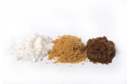[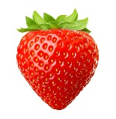](http://www.google.nl/url?sa=i&rct=j&q=&esrc=s&source=images&cd=&cad=rja&uact=8&ved=0ahUKEwjM4oC7hf3YAhUDC8AKHcqgBgcQjRwIBw&url=http://www.missethoreca.nl/restaurant/blog/2017/5/culi-column-michel-van-der-kroft-de-puike-aardbei-101271774&psig=AOvVaw12zLKYlX6i9OrqtVaB7nmP&ust=1517310788883457)

Van Binnen en van Buiten stralen.

[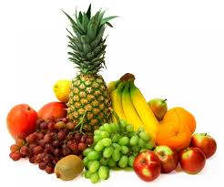](https://www.google.nl/imgres?imgurl=https%3A%2F%2Fwww.trendy-cocktails.nl%2Fincludes%2F_Files%2Fafbeeldingen%2FFruit%2FFruit.jpg&imgrefurl=https%3A%2F%2Fwww.trendy-cocktails.nl%2Fbar-verhuur%2Ffruitbar-huren.html&docid=LrmG3nTmIw3-jM&tbnid=hlHTpLTsGSr5MM%3A&vet=10ahUKEwiKmuT4vY7ZAhVUWsAKHa4FD9wQMwhhKBowGg..i&w=719&h=600&hl=nl&bih=676&biw=1366&q=tropisch%20fruit&ved=0ahUKEwiKmuT4vY7ZAhVUWsAKHa4FD9wQMwhhKBowGg&iact=mrc&uact=8)

[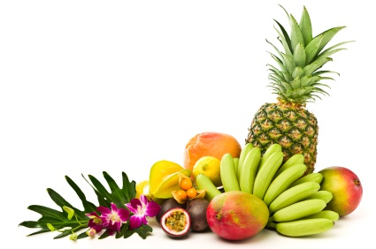](https://www.google.nl/url?sa=i&rct=j&q=&esrc=s&source=images&cd=&cad=rja&uact=8&ved=2ahUKEwiJ0oOZvo7ZAhXMCMAKHchbAxkQjRx6BAgAEAY&url=https%3A%2F%2Fwww.versfruitspecialist.nl%2Fc-2860591%2Ftropische-fruit%2F&psig=AOvVaw1t6bY3Jxr_ykngpqAsKHFd&ust=1517910110773905)[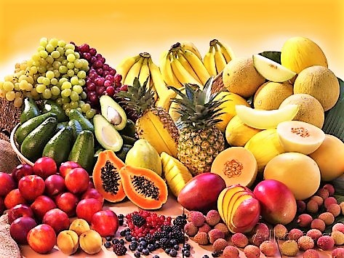](https://www.google.nl/url?sa=i&rct=j&q=&esrc=s&source=images&cd=&cad=rja&uact=8&ved=2ahUKEwjdi4X7vY7ZAhVsLMAKHSy-BasQjRx6BAgAEAY&url=https%3A%2F%2Ftallsay.com%2Fpage%2F4294987197%2Fzonnige-verleiding-van-tropisch-fruit-een-paar-recepten&psig=AOvVaw1t6bY3Jxr_ykngpqAsKHFd&ust=1517910110773905)